**POC on Spring MVC.**

**Purpose of this application –**

Purpose of the application is to create a simple Java Quiz application with Spring MVC framework which allows us to add questions and attend quiz. Motto is to learn Spring MVC by developing a simple application.

**Technologies Used –**

The Technologies involved are –

* Java 1.7
* Spring MVC
* JSP
* MY SQL
* JavaScript
* Maven 4.0

**Screenshot of the Pages-**

**Landing Screen -**

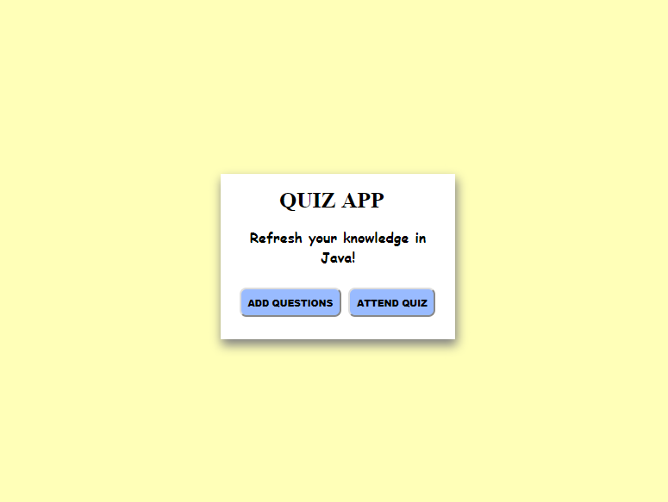

**Add Questions Screen –**

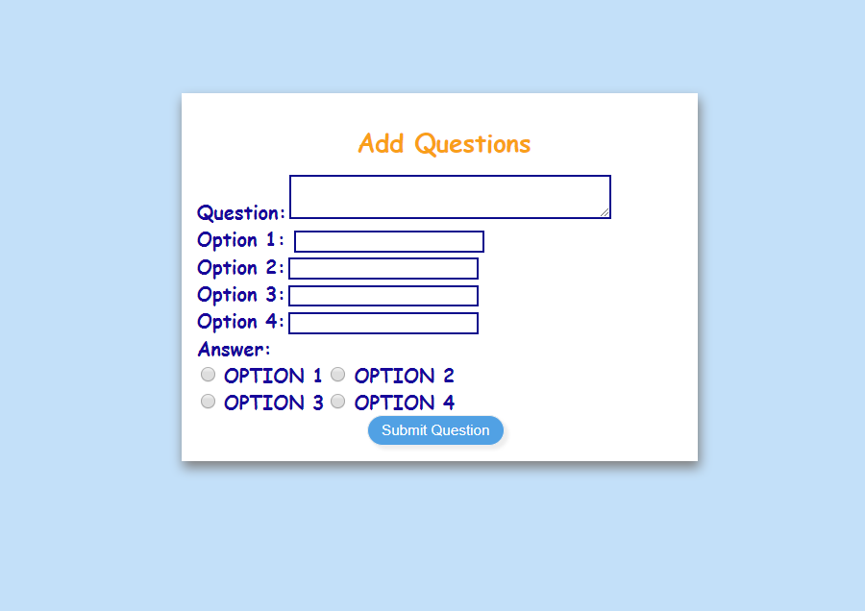

**Take Quiz Screen –**

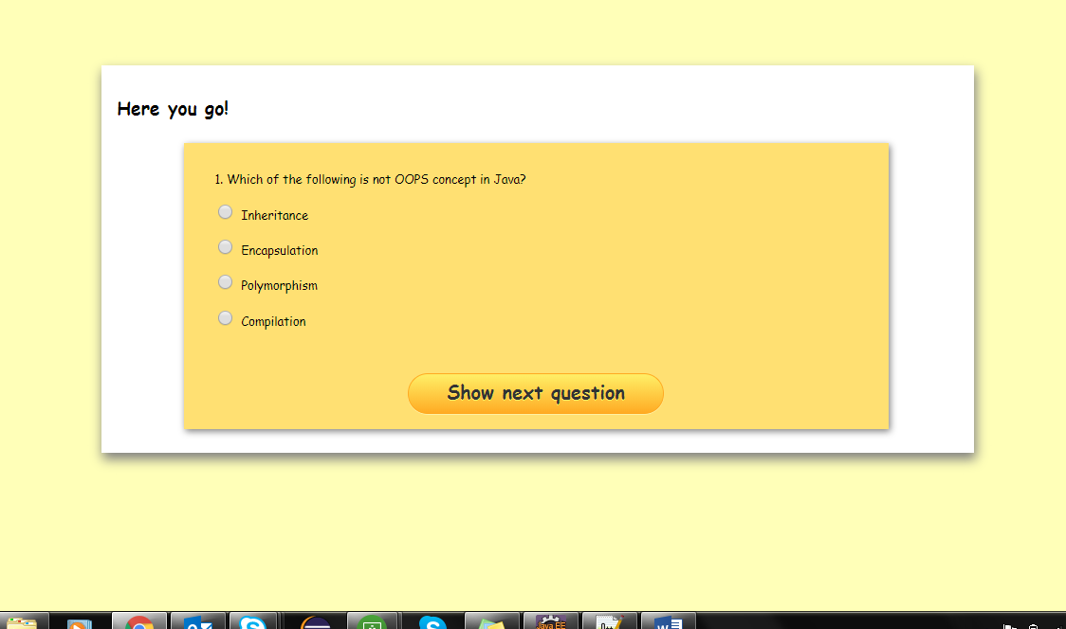

**Submit the Question –**

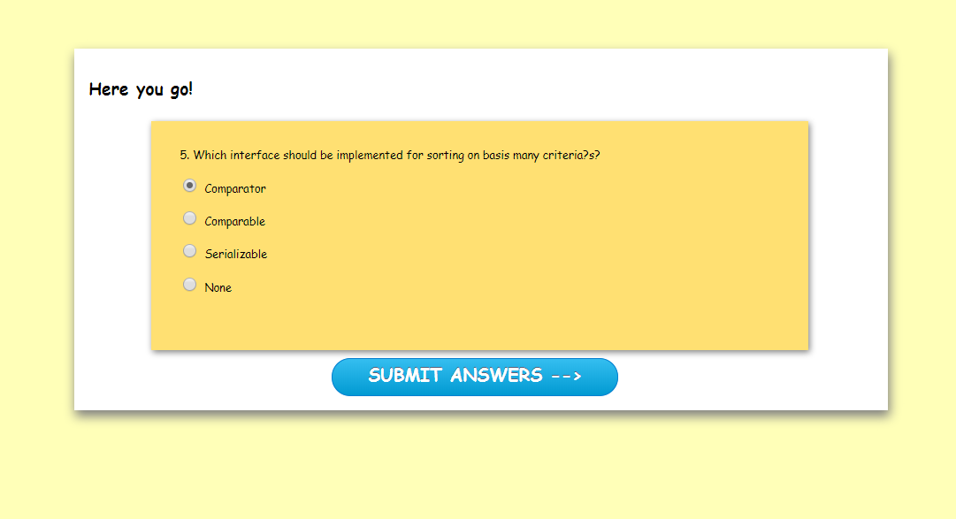

**The Last screen will display the result –**

